# C2- S5 - PRACTICE

*NOTE: check your* ***THEORY slides*** *to answer those questions!*

# EXERCISE 1 – GOOGLE CLASSROOM DATABASE

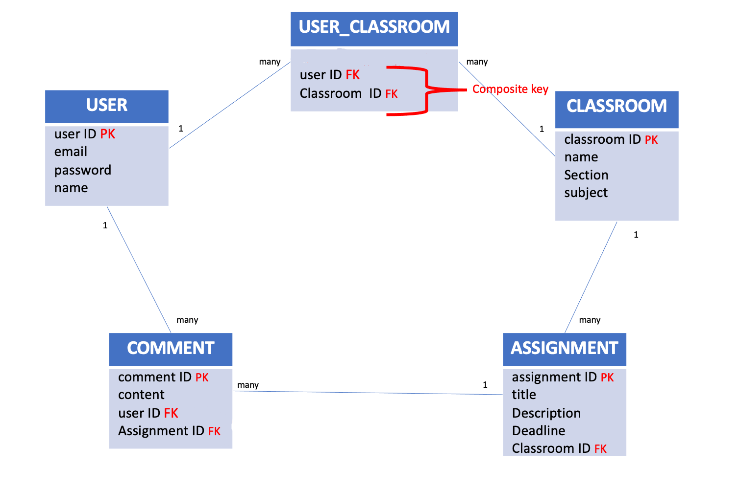

Here is the Entity Relation Diagram of the Google Classroom Database you designed in Chapter 1. You are now going to put it in MySQL!

**Q1 –** Write a statement to create the google classroom database, and to tell MySQL you are now working with it.

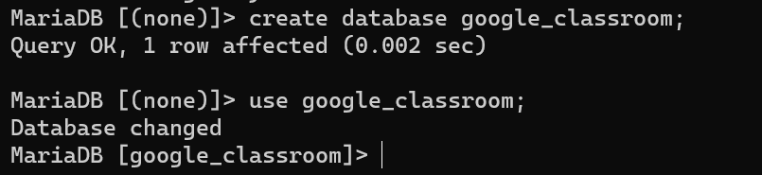

**Q2** – For each table (USER, USER_CLASSROOM, CLASSROOM, ASSIGNMENT, COMMENT), complete the following arrays, by specifying for each attribute:

* + The attribute type (SQL type) and size
  + Can be null or not?
  + Is a primary key or foreign keys?
* **USER TABLE**

|  |  |  |  |
| --- | --- | --- | --- |
| Attribute name | Type / size | Can be Null? | Key |
| userID | INT | NO | PRIMARY KEY |
| email | VARCHAR(200) | NO |  |
| password | VARCHAR(200) | NO |  |
| name | VARCHAR(200) | NO |  |

**USER_CLASSROOM TABLE**

|  |  |  |  |
| --- | --- | --- | --- |
| Attribute name | Type / size | Null? | Key |
| userID | INT | NO | FOREIGN KEY |
| classroomID | INT | NO | FOREIGN KEY |
|  |  |  |  |

**CLASSROOM TABLE**

|  |  |  |  |
| --- | --- | --- | --- |
| Attribute name | Type / size | Null? | Key |
| classroomID | INT | NO | PRIMARY KEY |
| name | VARCHAR(200) | NO |  |
| section | VARCHAR(200) | NO |  |
| subject | VARCHAR(200) | NO |  |

**ASSIGNMENT TABLE**

|  |  |  |  |
| --- | --- | --- | --- |
| Attribute name | Type / size | Null? | Key |
| signmentID | INT | NO | PRIMARY KEY |
| title | VARCHAR(200) | NO |  |
| Description | VARCHAR(400) | YES |  |
| Deadline | DATE | NO |  |
| classroomID | INT | NO | FOREIGN KEY |

**COMMENT TABLE**

|  |  |  |  |
| --- | --- | --- | --- |
| Attribute name | Type / size | Null? | Key |
| commentID | INT | NO | PRIMARY KEY |
| content | VARCHAR(400) | NO |  |
| userID | INT | NO | FOREIGN KEY |
| assignmentID | INT | NO | FOREIGN KEY |

**Q3** – Write the SQL statement to create the 5 tables with appropriate properties.

WARNING: Create the tables in the right order to respect the Foreign Key constraints.

* Users table:

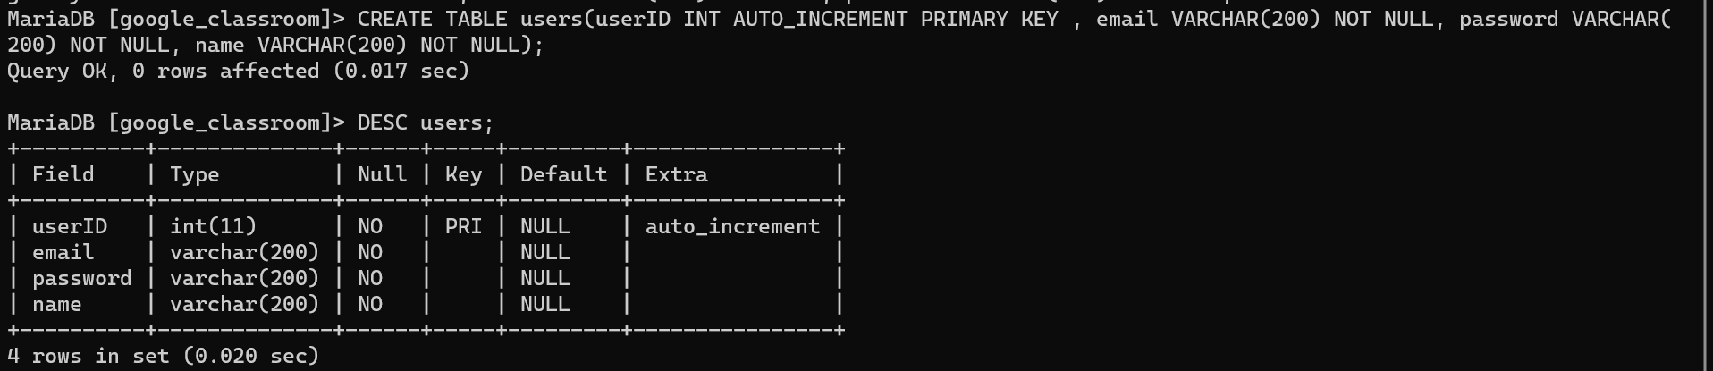

* Classrooms table:

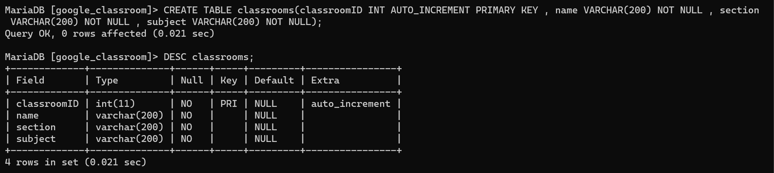

* User_classrooms table:

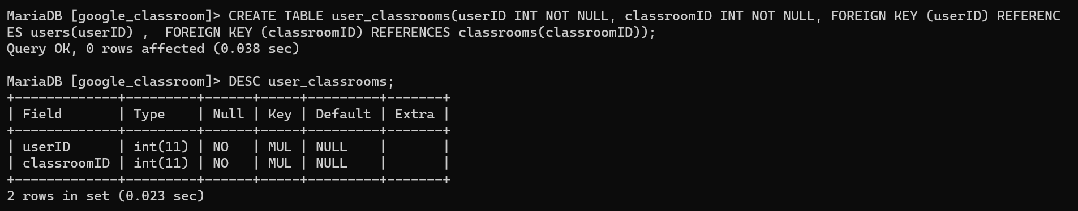

* Assignments table:

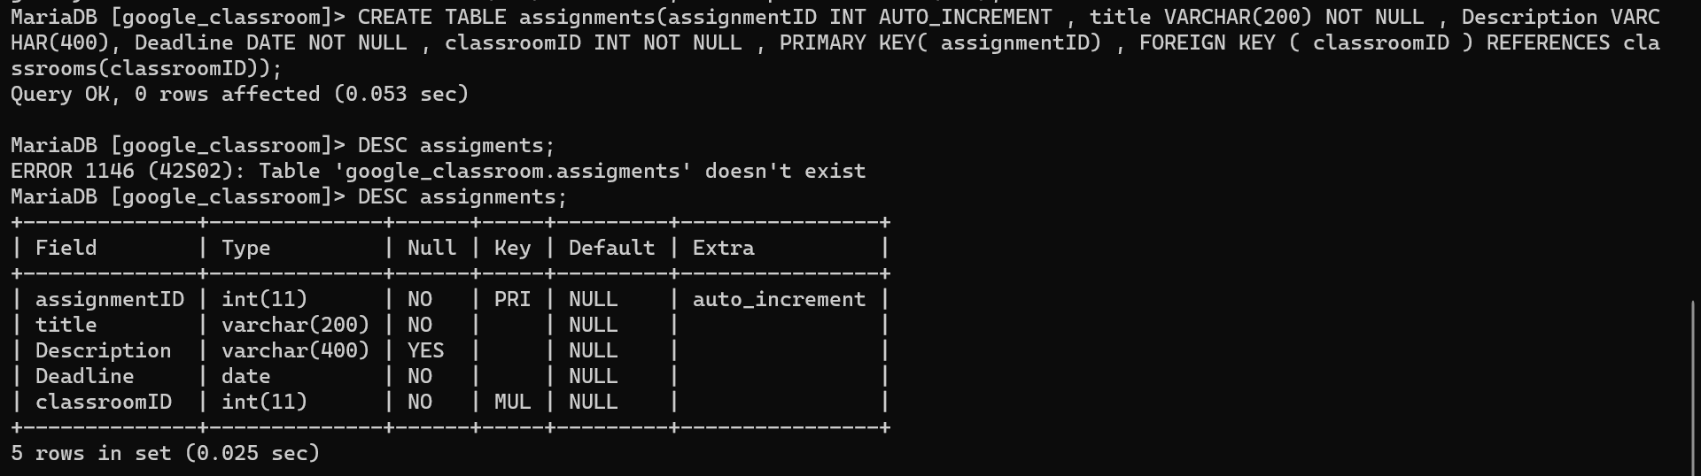

* Comments table:

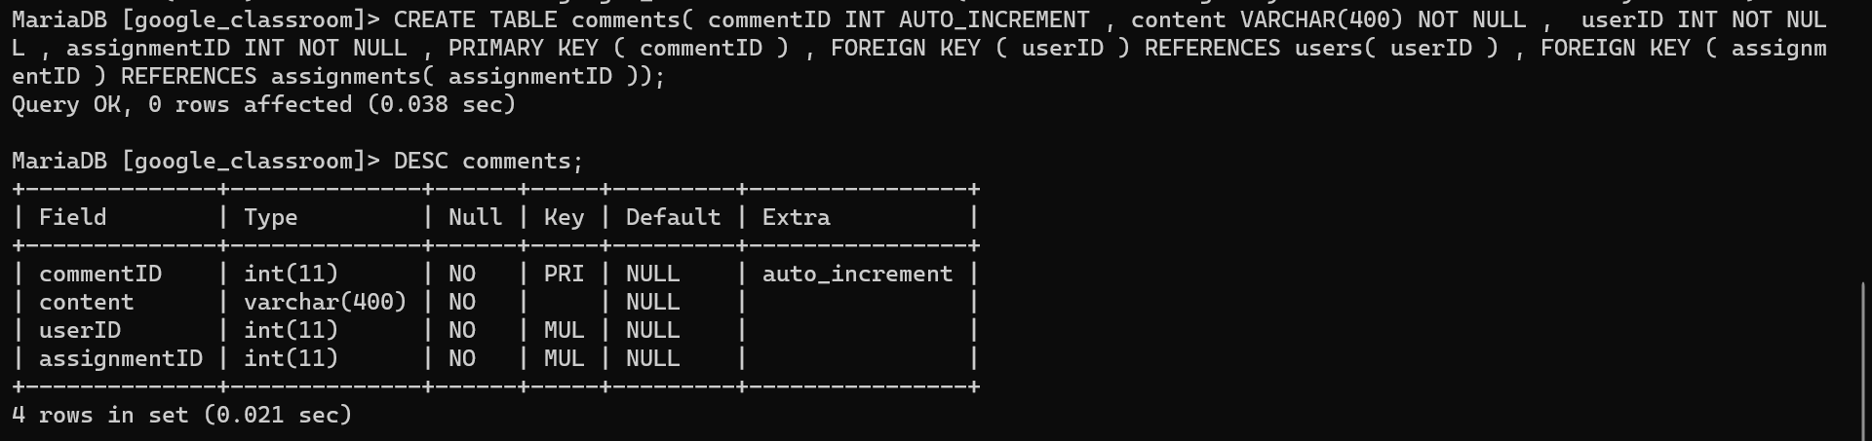

**Q4 –** Write statements to insert at least 3 records in each table.

* Users table:

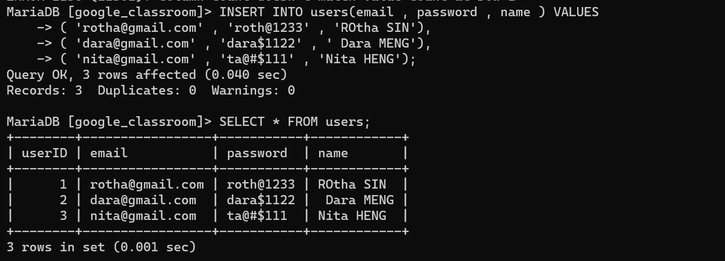

* Classrooms table:

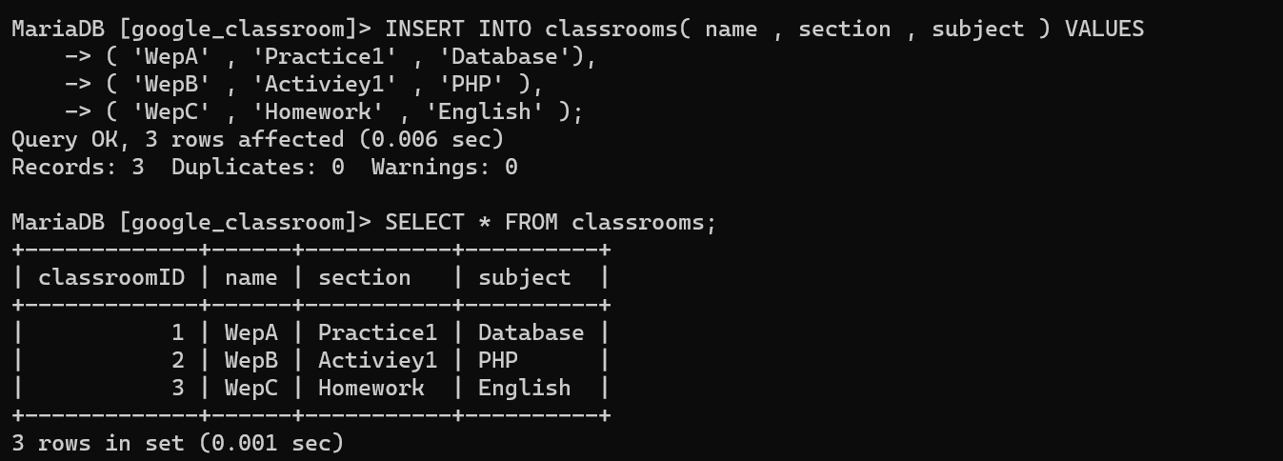

* User_classrooms table:

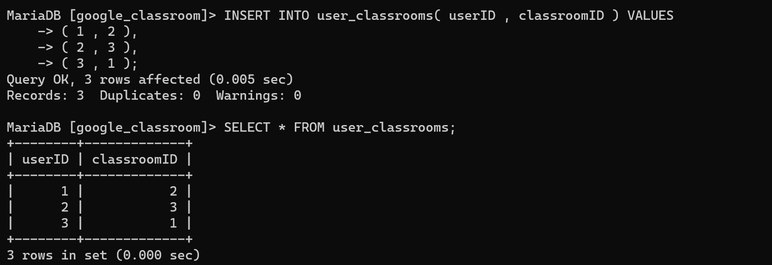

* Assignment table:

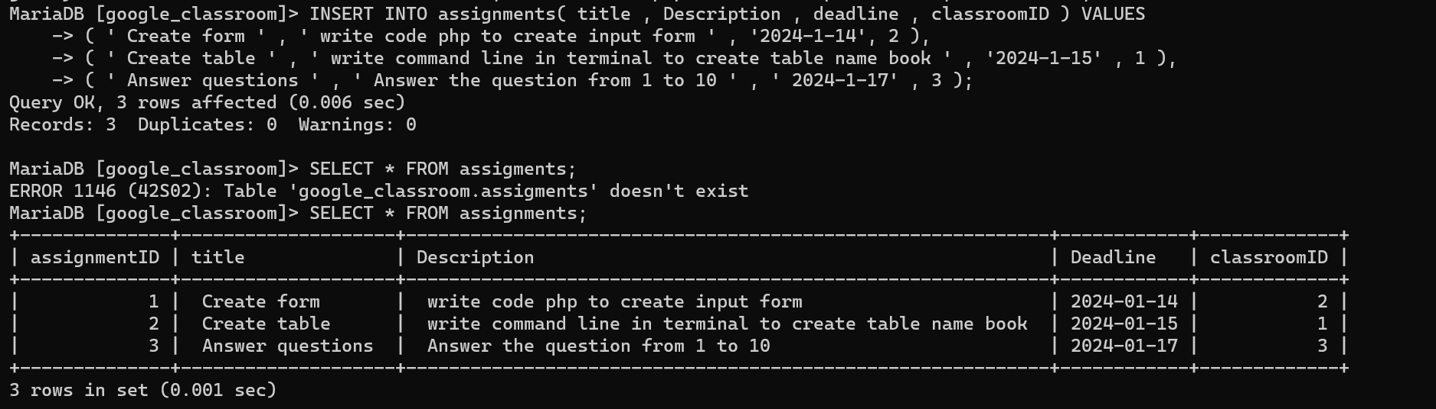

* Comments table:

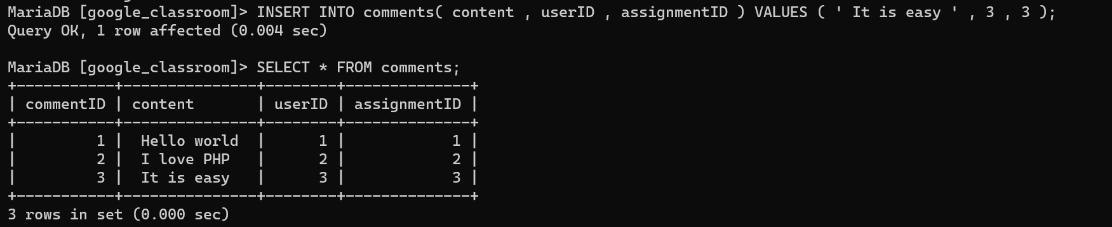

# EXERCISE 2 – FOODPANDA DATABASE

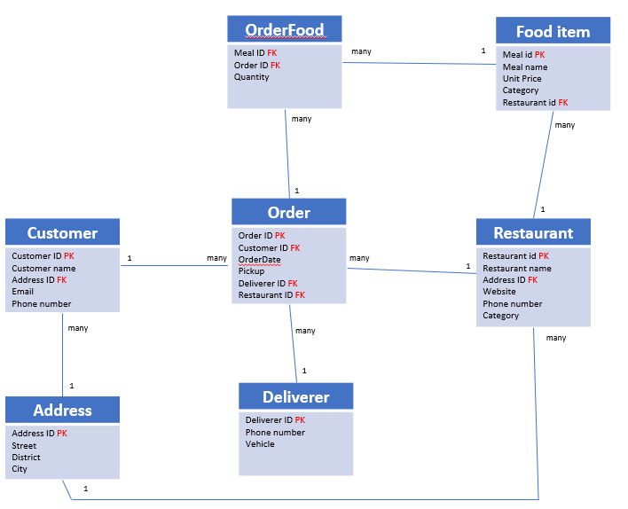

Here is the Entity Relation Diagram of the Foodpanda Database you designed in Chapter 1. You are now going to put it in MySQL!

**Q1 –** Write a statement to create the Foodpanda database, and to tell MySQL you are now working with it.

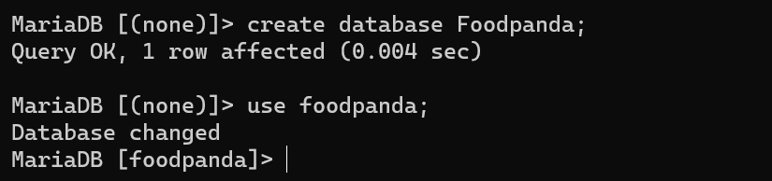

**Q2** – For each table of the database, complete the following array, by specifying for each attribute:

* + The attribute type (SQL type) and size
  + Can be null or not?
  + Is a primary key or foreign keys?

1. Address Table

|  |  |  |  |
| --- | --- | --- | --- |
| Attribute name | Type / size | Null? | Key |
| addressID | INT | NO | PRIMARY KEY |
| Street | VARCHAR(200) | NO |  |
| District | VARCHAR(100) | NO |  |
| city | VARCHAR(100) | NO |  |

1. Customers Table

|  |  |  |  |
| --- | --- | --- | --- |
| Attribute name | Type / size | Null? | Key |
| costumerID | INT | NO | PRIMARY KEY |
| costumerName | VARCHAR(100) | NO |  |
| addressID | INT | NO | FOREIGN KEY |
| Email | VARCHAR(100) | NO |  |
| phoneNumber | INT | NO |  |

1. Deliverers Table:

|  |  |  |  |
| --- | --- | --- | --- |
| Attribute name | Type / size | Null? | Key |
| delivererID | INT | NO | PRIMARY KEY |
| phoneNumber | INT | NO |  |
| vehicle | VARCHAR(20) | YES |  |

1. Restaurants Table:

|  |  |  |  |
| --- | --- | --- | --- |
| Attribute name | Type / size | Null? | Key |
| restaurantID | INT | NO | PRIMARY KEY |
| restaurantName | VARCHAR(100) | NO |  |
| addressID | INT | NO | FOREIGN KEY |
| website | VARCHAR(200) | YES |  |
| phoneNumber | INT | NO |  |
| category | VARCHAR(100) | NO |  |

1. Food_items Table:

|  |  |  |  |
| --- | --- | --- | --- |
| Attribute name | Type / size | Null? | Key |
| mealID | INT | NO | PRIMARY KEU |
| mealName | VARCHAR(100) | NO |  |
| unitPrice | INT | NO |  |
| Category | VARCHAR(100) | NO |  |
| rastaurantID | INT | NO | FOREIGN KEY |

1. Orders Table:

|  |  |  |  |
| --- | --- | --- | --- |
| Attribute name | Type / size | Null? | Key |
| orderID | INT | NO | PRIMARY KEY |
| costumerID | INT | NO | FOREIGN KEY |
| orderDate | DATE | NO |  |
| pickUp | VARCHAR(200) | NO |  |
| delivererID | INT | NO | FOREIGN KEY |
| restaurantID | INT | NO | FOREIGN KEY |

1. Order_food Table:

|  |  |  |  |
| --- | --- | --- | --- |
| Attribute name | Type / size | Null? | Key |
| mealID | INT | NO | FOREIGN KEY |
| orderID | INT | NO | FOREIGN KEY |
| quantity | INT | NO |  |

**Q3** – Write the SQL statement to create the tables with appropriate properties.

WARNING: Create the tables in the right order to respect the Foreign Key constraints.

* Address table:

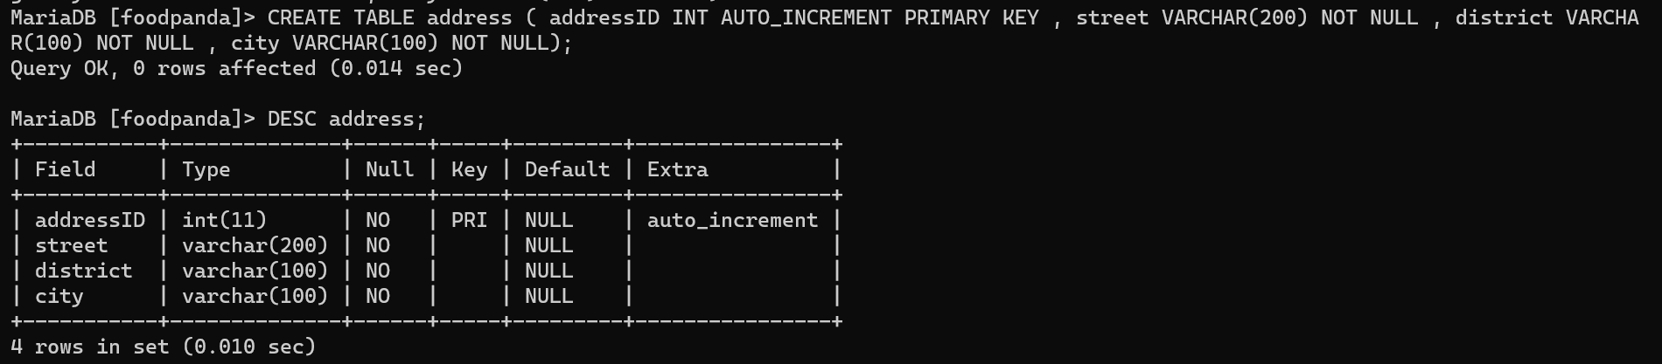

* Costumers table:

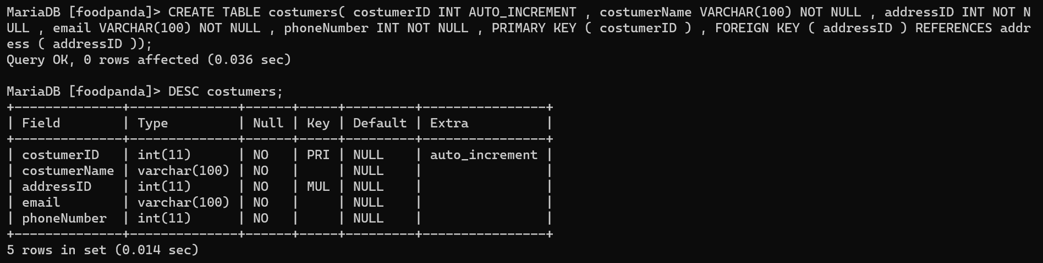

* Deliverers table:

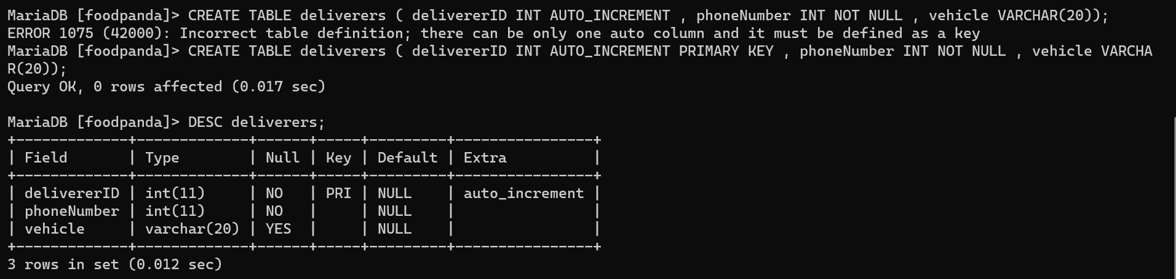

* Restaurants table:

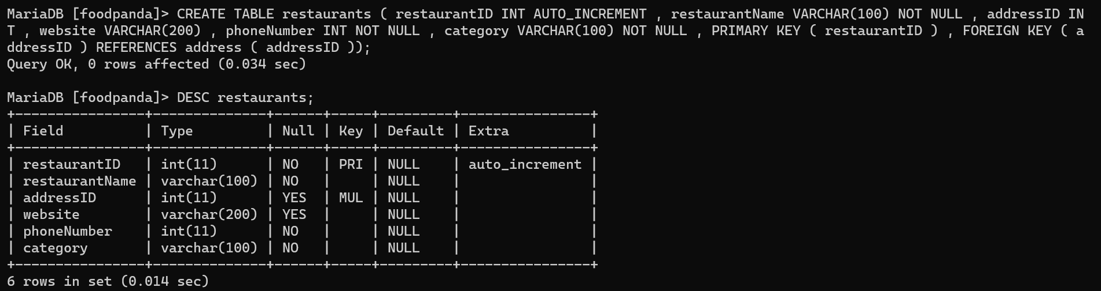

* Fooditems table:

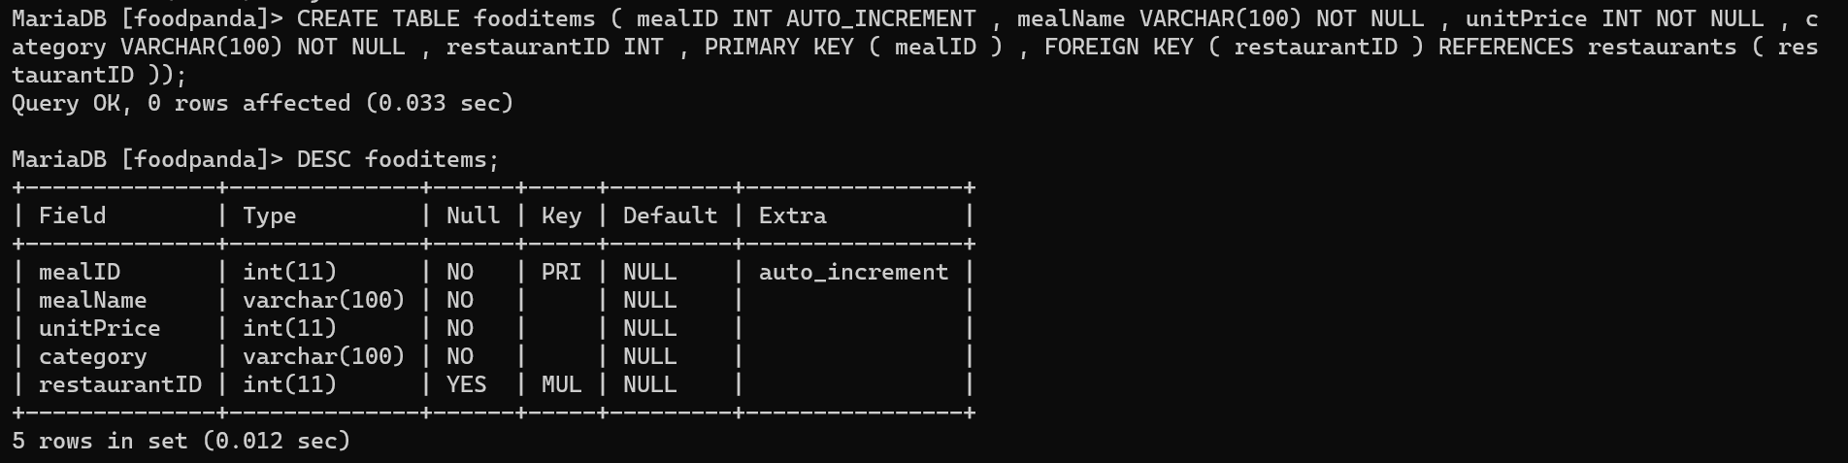

* Orders table:

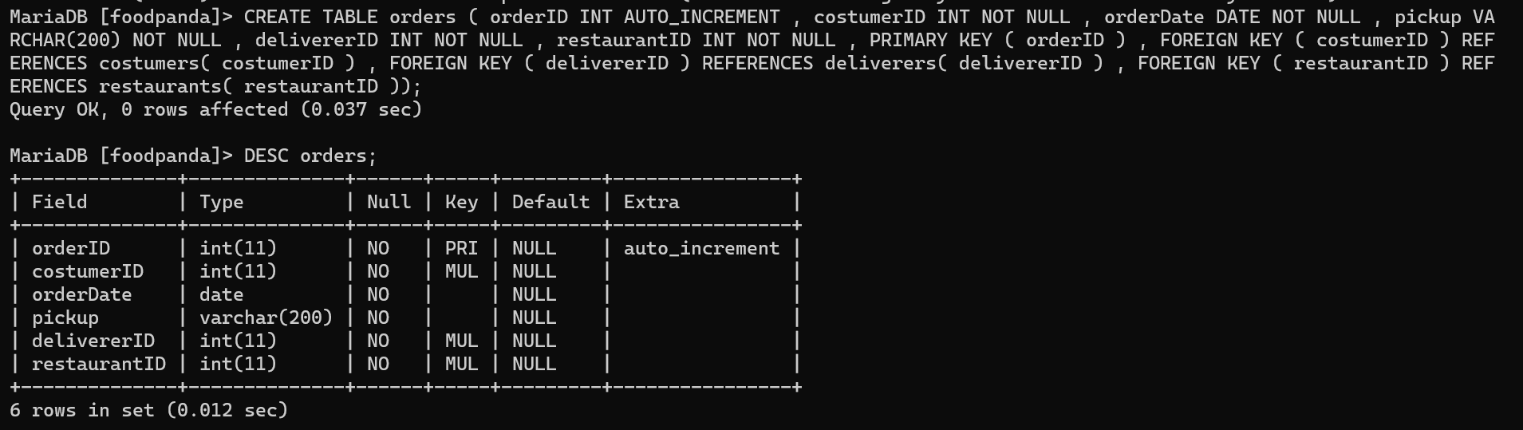

* Order_foods table:

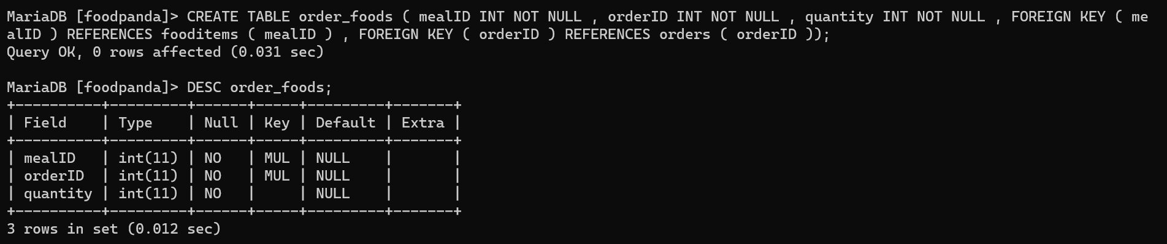

**Q4 –** Write statements to insert between 2 and 4 records in each table.

* Address table:

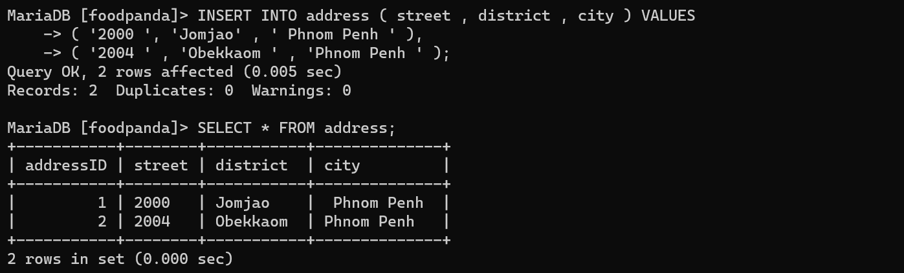

* Costumers table:

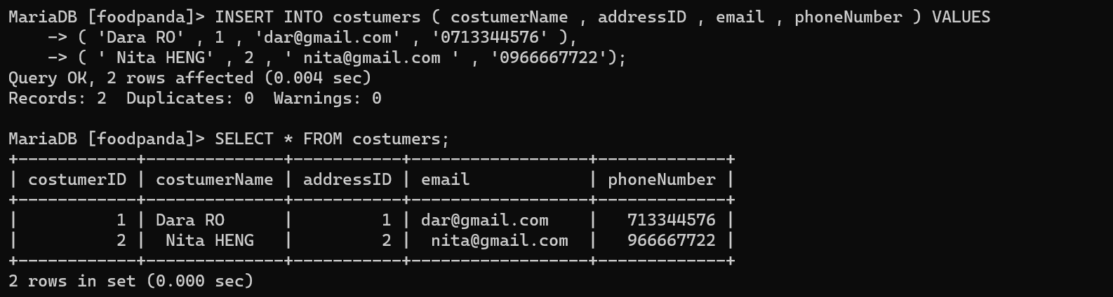

* Deliverers table:

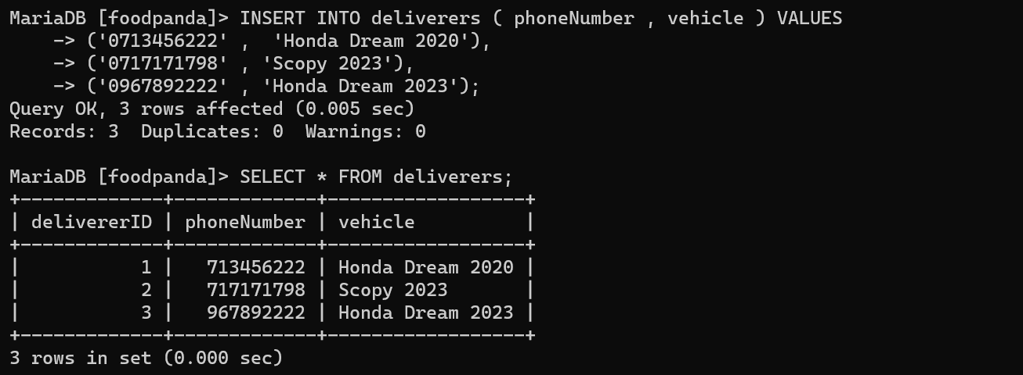

* Restaurants table:

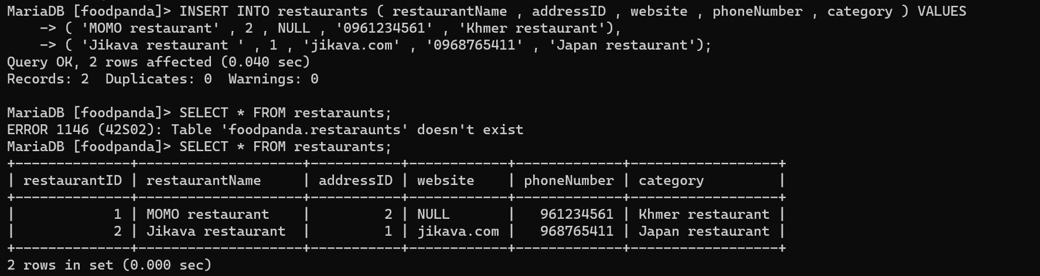

* Fooditems table:

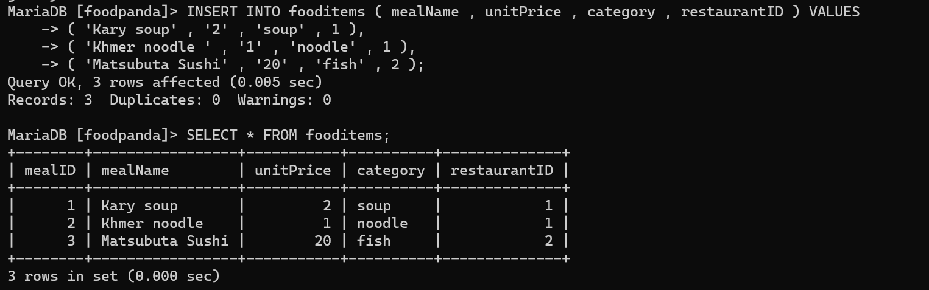

* Orders table:

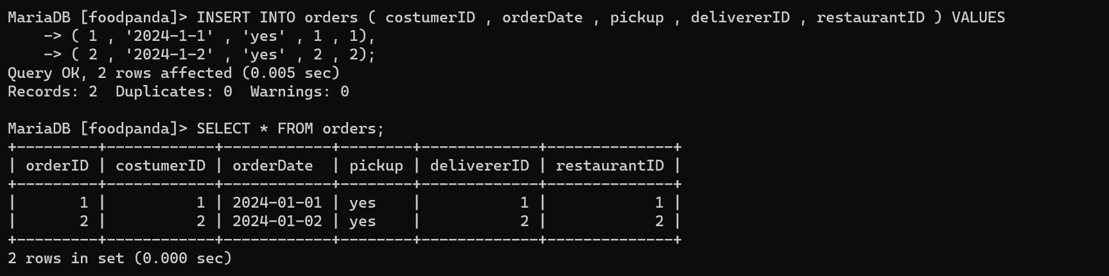

* order_foods table:

